*HARISH T S*

*DEPARTMENT OF ELECTRICAL AND ELECTRONICS ENGINEERING*

*M.KUMARASAMY COLLEGE OF ENGINEERING*

*KARUR, TAMIL NADU, INDIA*

*harishsakthivel88831@gmail.com*

*GUIDED BY*

*Mr.V.JAYAKUMAR AP/EEE*

*DEPARTMENT OF ELECTRICAL AND ELECTRONICS ENGINEERING*

*M.KUMARASAMY COLLEGE OF ENGINEERING*

*KARUR, TAMIL NADU, INDIA*

*jk2020jv@gmail.com*

*JEYANTHRAGAV K*

*DEPARTMENT OF ELECTRICAL AND ELECTRONICS ENGINEERING*

*M.KUMARASAMY COLLEGE OF ENGINEERING*

*KARUR, TAMIL NADU, INDIA*

*jeyanthragav07@gmail.com*

c

*HARISH S*

*DEPARTMENT OF ELECTRICAL AND ELECTRONICS ENGINEERING*

*M.KUMARASAMY COLLEGE OF ENGINEERING*

*KARUR, TAMIL NADU, INDIA*

*harishsenthil31@gmail.com*

*GOWTHAM R*

*DEPARTMENT OF ELECTRICAL AND ELECTRONICS ENGINEERING*

*M.KUMARASAMY COLLEGE OF ENGINEERING*

*KARUR, TAMIL NADU, INDIA*

*gowthamramasamy17@gmail.com*

***Abstract***— Agriculture faces critical challenges such as water scarcity, high energy costs, and a need for sustainable practices. Traditional irrigation systems often result in inefficient water use, increasing resource waste and operational expenses. This project presents a Solar-Powered Irrigation System enhanced with Artificial Intelligence (AI) to optimize water use, reduce energy dependence, and boost crop productivity. The system leverages solar energy and AI-based decision-making to autonomously manage irrigation, using real-time soil and weather data to ensure efficient and sustainable water distribution.

# **1.Introduction**

Agricultural irrigation systems play a crucial role in ensuring adequate water distribution, optimizing crop yield, and preserving water resources. Traditional irrigation methods often rely on manual or timer-based approaches, which can lead to water wastage, increased costs, and inconsistent results, particularly in regions facing water scarcity. The rapid advancements in Artificial Intelligence (AI) and Internet of

Things (IoT) technologies now offer promising solutions for enhancing irrigation efficiency through automation, monitoring, and data-driven decision-making.

Moreover, the AI system can continuously learn from environmental data and adapt irrigation strategies to suit different crop types, soil conditions, and climate variations. This smart approach enables farmers to maximize yields while minimizing resource usage and environmental impact.

This paper presents an AI-based approach for monitoring and controlling irrigation systems, focusing on the integration of sensor networks, machine learning models, and decision-making algorithms. We explore various components, including data collection from sensor nodes, real-time analytics, and automated control systems that regulate irrigation schedules based on predictive modeling. The results demonstrate the potential benefits of AI-driven irrigation, including water savings, increased crop productivity, and enhanced resilience against climate variability. This research aims to contribute to the development of sustainable agriculture practices and advance the practical applications of AI in resource management.

# **2.Overview of the Smart irrigation**

**2.1 Sensors for Data Collection**

Soil Moisture Sensor: Measures soil moisture levels to determine the amount of water required for optimal plant growth.

Temperature and Humidity Sensor: Monitors environmental conditions to assess the overall climate's effect on crop water needs.

Light Sensor (Optional): Detects sunlight exposure, as water needs vary based on light intensity.

MQ-6 Gas Sensor: Detects gas levels, which can be used to monitor soil quality and identify harmful gases that may affect crops.

**2.2 Data Processing and Analysis**

Data Acquisition:All sensor data is collected and sent to a microcontroller or microprocessor (such as NodeMCU or Arduino). Data Preprocessing: The raw data is cleaned and processed for further analysis, which includes normalizing and filtering out noise from the sensor inputs.

AI and Machine Learning Models: Models such as regression algorithms or neural networks can predict the amount of water needed based on historical data, current conditions, crop type, and growth stage.

Predictive Analysis: Using past data, machine learning models can forecast soil moisture levels or rainfall patterns to anticipate irrigation needs.

**2.3 Decision-Making and Control System**

Irrigation Decision Logic: AI models determine the optimal irrigation schedule and the precise amount of water required.

Automated Control of DC Pump: Based on AI decisions, the system activates or deactivates the pump to irrigate the field. This is connected through relay modules to control the power to the pump.

Water Flow Regulation: The AI system can regulate water flow depending on real-time conditions, reducing water waste and ensuring efficient water distribution.

**2.4 Remote Monitoring and Control (IoT)**

Wireless Communication (Wi-Fi/NodeMCU): Enables data transmission to a cloud server or mobile app for real-time monitoring.

User Interface: A mobile or web app allows farmers to monitor real-time conditions, receive notifications, and manually override the system if necessary.

**2.5 Benefits of AI-Based Irrigation Systems**

**Water Conservation:** AI models ensure only the necessary amount of water is applied, minimizing water wastage.

**Cost Savings:** Automated control reduces labor costs and optimizes energy usage, especially with solar integration.

Enhanced Crop Yield: By maintaining optimal moisture levels, the system helps improve plant health and crop yield.

**Environmental Sustainability:** Solar power and optimized water usage contribute to a more sustainable agricultural system.

**2.6 Future Enhancements**

**Weather Forecast Integration:** Using external weather forecasts to adjust irrigation plans based on predicted rainfall.

**Crop-Specific Optimization:** AI can learn specific water needs for different crops to further fine-tune irrigation levels.

**Anomaly Detection:** Using AI to identify abnormal sensor readings, which could indicate issues like leaks, sensor faults, or soil contamination. This intelligent irrigation system provides a complete, automated, and efficient solution for managing water resources in agriculture, leading to improved productivity, sustainability, and resource conservation.

# 

# **Design and Architecture**

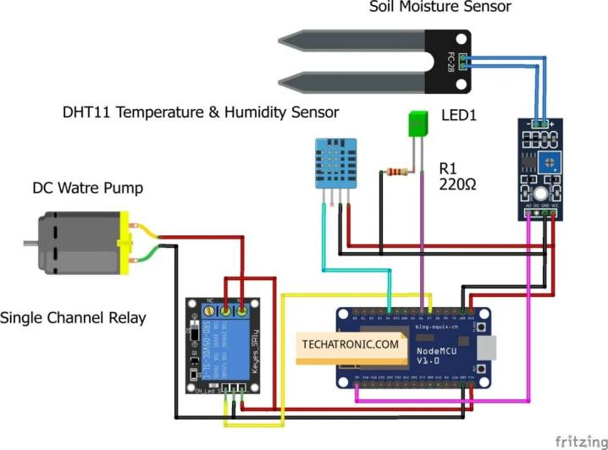

Fig 3.1

## **3.1 Sensors and Data Acquisition**

The smart weighing system relies on load sensors embedded in the loader's hydraulic arms or bucket system. These sensors measure the hydraulic pressure or force exerted by the

Fig 3.1.1

material in the bucket and convert it into a digital signal representing the material’s weight.

## **3.2 Signal Processing and Data Interpretation**

The signals from the sensors are transmitted to a microcontroller that processes the data using calibration algorithms. These algorithms adjust for variables like bucket position and the angle of the loader’s arm to provide an accurate weight reading.

## **3.3 User Interface and Control System**

The weight data is displayed on a user-friendly interface in the operator's cabin, showing real-time measurements. The system also includes warning signals to alert operators in cases of overload, ensuring that the payload remains within safe limits.

## **3.4 Connectivity and Data Transmission**

The system is integrated with IoT technology, allowing the weight data to be transmitted to a central system or cloud platform.

**3.5 Components**

Transformer: Converts high-voltage AC power to a lower voltage suitable for the pump or other AC-powered components. This step-down process ensures that devices receive power within safe operating ranges.

Rectifier: Converts the AC voltage from the transformer into DC voltage, which is necessary for the microcontroller and certain DC-powered components like the sensors and pumps.

.

Voltage Reducer: Lowers the rectified DC voltage to levels that are safe for sensitive components such as the NodeMCU and sensors, often around 3.3V or 5V. This prevents overheating or damage to these low-power devices.

Moisture and Humidity Sensors: These sensors monitor soil moisture levels and environmental humidity, providing the NodeMCU with data essential for deciding when to irrigate. This

helps avoid over-watering or under-watering the crops

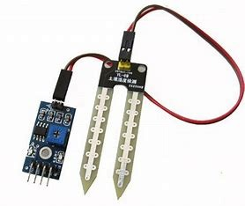

Fig 3.5.1

.

DC Pump: Responsible for the irrigation itself, the pump is activated by the microcontroller to deliver water when needed. DC pumps are preferred in IoT applications for their compatibility with low-voltage control systems​

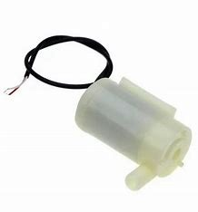

Fig 3.5.2

NodeMCU (ESP8266): A microcontroller with built-in Wi-Fi capability, allowing it to gather data from sensors, process it locally or through AI-based cloud models, and control the pump accordingly. It also supports remote monitoring and adjustments via a mobile app or web interface​

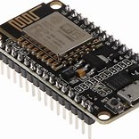

Fig 3.5.3

**4.Implementation and Testing**

**4.1 Hardware SetupComponents and Wiring:** Begin by setting up all components. Connect the soil moisture sensor to the NodeMCU’s analog input pin to receive data about soil moisture levels. The humidity sensor (e.g., DHT11) should connect to another input pin, providing environmental data. Connect the relay module to the DC pump to control water flow based on soil readings.Power Supply: Use a rectifier and voltage reducer to ensure each component receives the correct voltage. For example, the NodeMCU typically requires 3.3V or 5V, while the DC pump might need a higher voltage, supplied separately from the main power source.

**4.2 Software-development-microcontroller Programming:**

Use Arduino IDE to write and upload code to the NodeMCU. The code should read sensor data and make decisions based on threshold values for soil moisture and humidity. Integrate libraries for sensor handling (such as DHT or soil moisture libraries) and control the relay for the pump.AI Model Integration: If you’re using AI, integrate a basic machine learning model on the NodeMCU or through cloud services. This model can predict optimal irrigation times based on historical data, environmental conditions, and soil moisture readings.Cloud and IoT Connectivity: Set up the NodeMCU to communicate with an IoT platform (e.g., Blynk or ThingSpeak) for real-time data monitoring and remote control. This allows users to receive notifications, monitor sensor data, and manually control the pump if needed.

**4.3 TestingUnit Testing:**

Verify that each component operates correctly in isolation. Test the soil moisture sensor by manually adjusting moisture levels in the soil and observing the sensor’s output. Similarly, test the humidity sensor by exposing it to varying humidity levels.System Testing: Assemble the full system and test the response to different conditions. Place the moisture sensor in dry soil, observe the NodeMCU’s response, and confirm that it activates the pump. Field Testing: Deploy the system in a real or simulated agricultural setting to evaluate its performance over time. Collect data on water usage, soil moisture maintenance, and power consumption. This step will reveal the system’s effectiveness and any areas needing refinement.

# **4.4 Performance Evaluation and Calibration**

# Calibration: Fine-tune the soil moisture threshold and AI model parameters based on observed data to ensure accurate irrigation. Adjust values to prevent over-watering or under-watering, optimizing for both water savings and crop health.

# Reliability Testing: Test the system’s reliability in different environmental conditions (e.g., extreme heat, humidity variations) to ensure durability. Measure performance under continuous use to assess long-term stability and robustness.

# **4.5 Data Analysis and Optimization**

# Review collected data on soil moisture, pump activation times, and water usage. This analysis can improve the model by identifying patterns in moisture loss or adjusting irrigation timing based on seasonal weather.

# Through these steps, the system should be refined for efficiency and stability, with IoT-based controls and AI-driven automation enhancing its capabilities

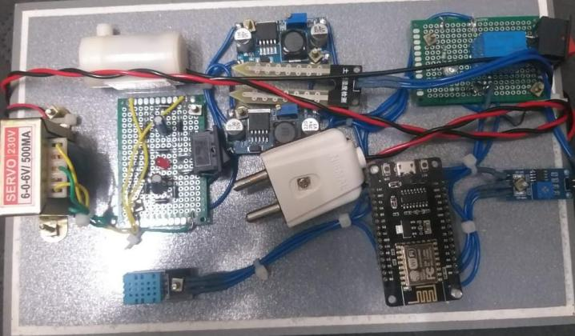

Fig 4.1

# **5.Advantages of Smart Irrigation**

Water Efficiency: The system uses soil moisture and weather data to optimize watering, reducing water usage by delivering precise amounts only when needed. This is especially beneficial in water-scarce regions where conservation is essential​

Improved Crop Health and Yield: By monitoring environmental conditions and soil moisture, the system helps maintain optimal hydration for plants. Consistent and balanced watering can enhance plant growth, leading to healthier crops and potentially higher yields

​

Cost Savings: Automated irrigation reduces labor costs as it requires minimal human intervention. Additionally, optimized water usage can lower utility bills and reduce reliance on manual irrigation, making it cost-effective for larger-scale farms​

Environmental Sustainability: Efficient water management reduces the strain on natural water sources. AI-driven predictions further minimize resource waste, supporting sustainable agricultural practices​

Remote Monitoring and Control: With components like NodeMCU, the system can be accessed remotely, allowing users to monitor soil conditions and control irrigation schedules from mobile devices. This feature is valuable for large farms or areas that require constant supervision​

Scalability: The system can be adapted for various scales, from small gardens to extensive agricultural fields, making it versatile and suitable for diverse applications in farming and horticulture.

1. **Challenges and Limitations**
   1. **Technical Complexity**

Hardware and Integration: Combining various sensors (moisture, humidity) and components (NodeMCU, DC pump, rectifier) can be complex. The need to regulate voltage for each component and manage wiring and compatibility issues may require technical expertise, making setup challenging for non-specialists​Programming and AI Model Development: Building and training an AI model to make accurate irrigation predictions based on environmental data can be demanding, especially for small farms or DIY users who may lack machine learning expertise. Additionally, processing limitations on microcontrollers like NodeMCU can restrict the complexity of on-device AI models, sometimes requiring cloud resources which add cost and dependency on internet connectivity​

**6.2 Cost and Infrastructure Limitations**

Initial Investment: Setting up smart irrigation with AI requires investment in sensors, microcontrollers, cloud services, and a reliable internet connection. For small-scale farmers, the upfront cost may be prohibitive, even if long-term savings on water and labor are significant.Internet and Power Dependency: Rural or remote farms may have limited access to stable power and internet, both of which are essential for IoT devices to function effectively. Power interruptions can disrupt irrigation schedules, and internet outages can halt data transmission to cloud platforms or mobile apps, reducing control and monitoring capabilities​

# **6.3 Environmental and Physical Constraints**

# Sensor Calibration and Maintenance: Sensors can degrade over time due to exposure to moisture, soil acidity, or temperature fluctuations, leading to inaccurate readings. Regular calibration and maintenance are required to ensure reliable data, adding to operational demands​

# Weather Variability: Sudden weather changes, such as unexpected rain, may not be immediately accounted for by the AI model, potentially leading to over-watering. Real-time data from additional sources like local weather stations may help, but integrating this data can be complex and costly.

# **6.4 Data and Model Limitations**

# Data Requirements for AI Models: Effective AI irrigation systems require substantial data on soil conditions, weather patterns, and crop needs, ideally collected over time to improve model accuracy. Limited or low-quality data can result in inaccurate predictions, leading to ineffective irrigation scheduling​

# Model Generalization: AI models may struggle to adapt to varying crop types, soil compositions, and regional climates without specific customization. This can limit the system’s versatility across different agricultural setups unless tailored models are used, which can add development costs.

# **7. Conclusion and Future Work**

In conclusion, an AI-based smart irrigation system offers promising benefits for water conservation, crop health, and efficient farm management. The integration of sensors, microcontrollers, and AI-driven predictive models enables precise water delivery based on real-time soil and environmental data, reducing water waste and improving crop yield​.

Remote monitoring capabilities also make it convenient for farmers to manage irrigation schedules, even from afar, enhancing productivity and reducing labor costs.

However, challenges such as technical complexity, maintenance needs, and dependence on reliable power and internet infrastructure can limit widespread adoption, particularly in resource-limited settings​

. Furthermore, the initial setup costs may be a barrier for small-scale farmers despite the potential for long-term savings.

Future improvements in sensor technology, reduced hardware costs, and more robust AI models could help overcome these limitations, making smart irrigation systems increasingly accessible and effective. Ultimately, such systems have the potential to play a crucial role in sustainable agriculture, especially as water conservation becomes an ever more critical priority in agriculture globally.​

**References**

Kumar, S., & Sharma, M. (2022). AI and IoT-Based Smart Irrigation System for Precision Agriculture. Springer.

Patel, M. L., Singh, A., & Verma, R. (2021). "Smart Irrigation System Using Machine Learning and IoT: A Solution for Sustainable Agriculture," in Proceedings of the 2021 International Conference on Sustainable Energy and Environment Systems (pp. 345-350). IEEE.

Elhady, A., & Chen, Y. (2020). Intelligent Irrigation Systems with IoT and AI Technologies. Wiley.

Zhang, Q. (2021). Precision Agriculture Technology for Crop Farming. Academic Press.

Dhanasekaran, C., & Ramachandran, M. (2022). Internet of Things (IoT) for Automated and Smart Applications. Elsevier.